1. 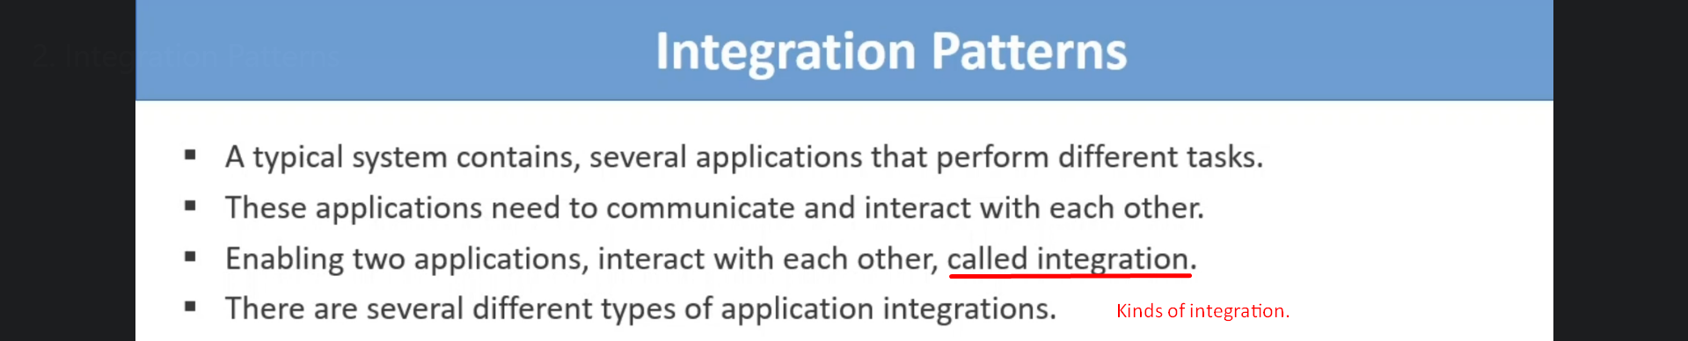

Filed Based Integration

1. 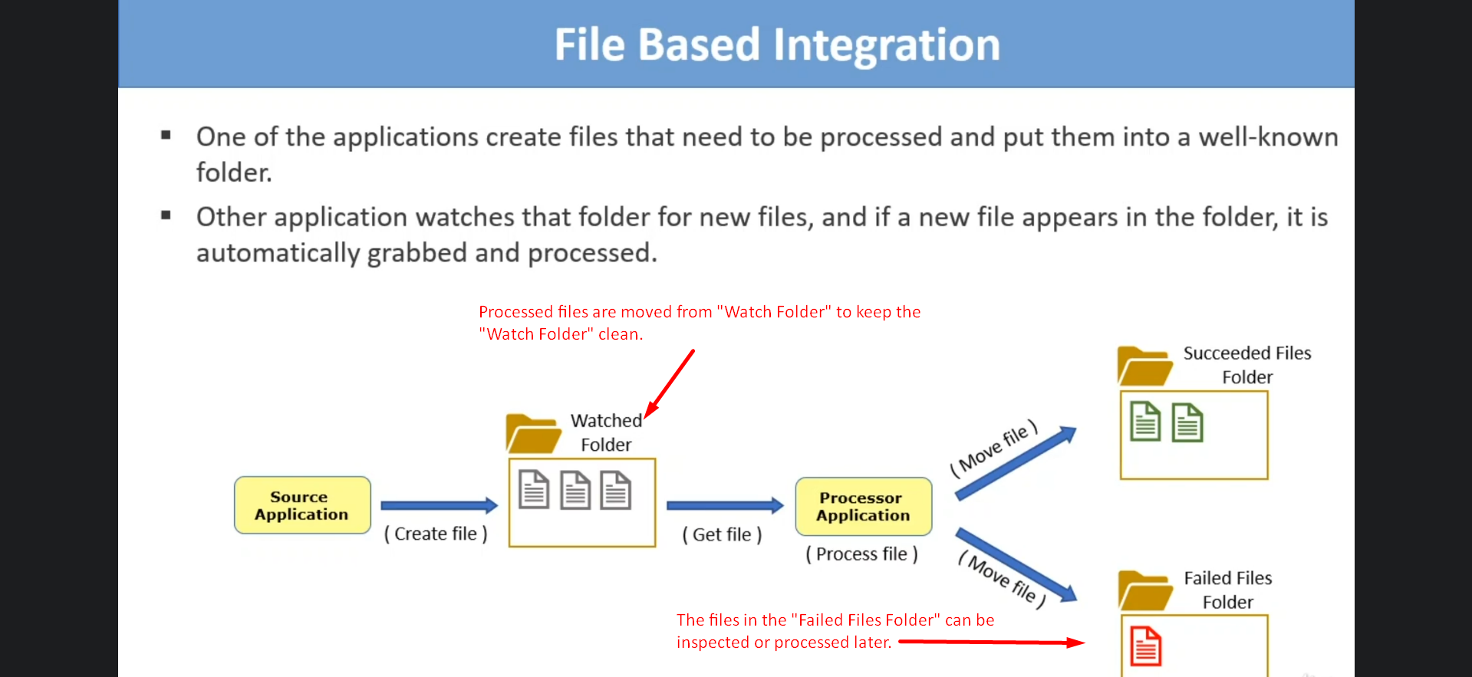
2. The files which are processed either successfully or with failures are moved to some other folders to keep the “**watch folder clean**”.
3. The files in the “Failed Files Folder” can be inspected and processed later.

Shared Database Integration

1. 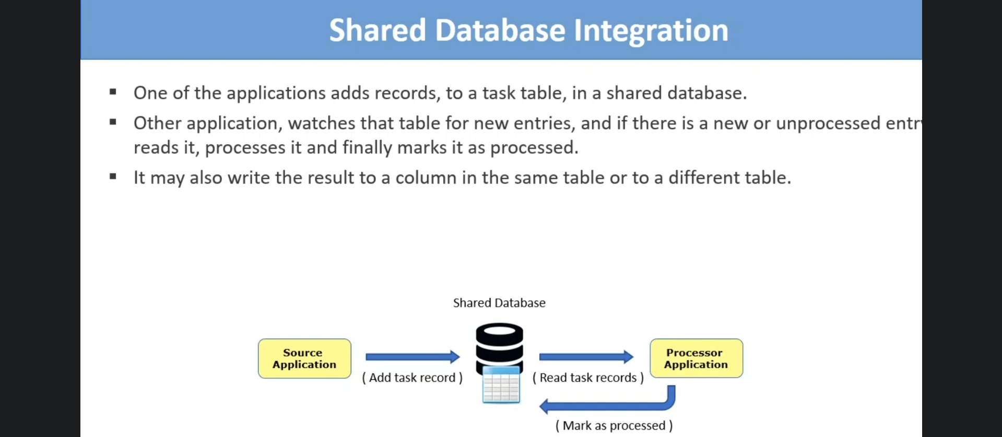

Direct Connection Integration

1. 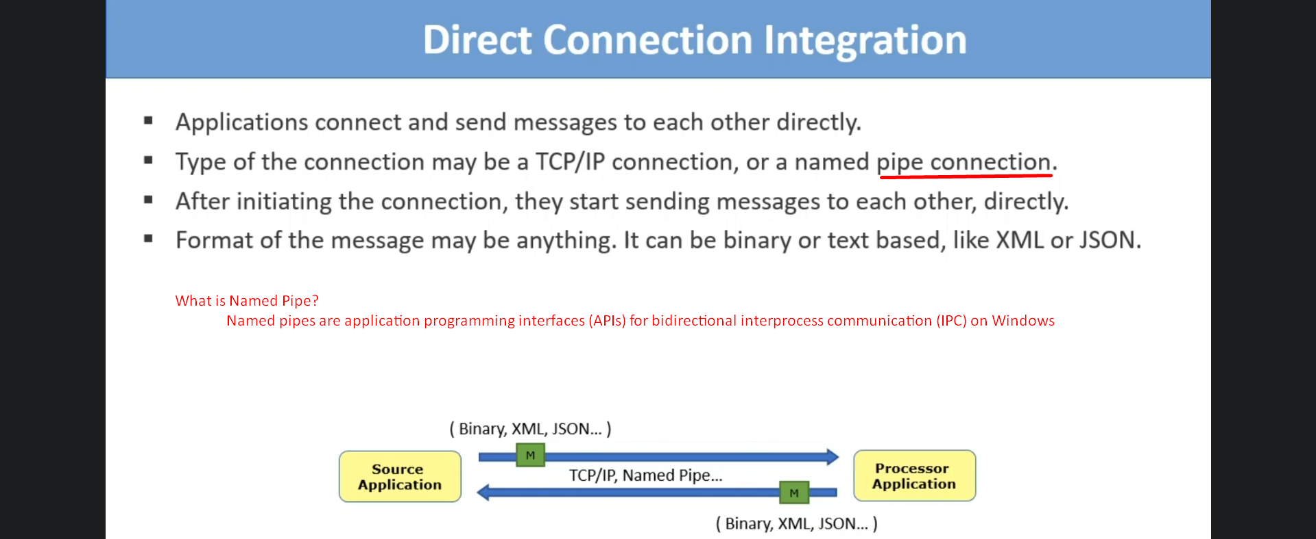

Asynchronous Messaging Using a Message Broker

1. 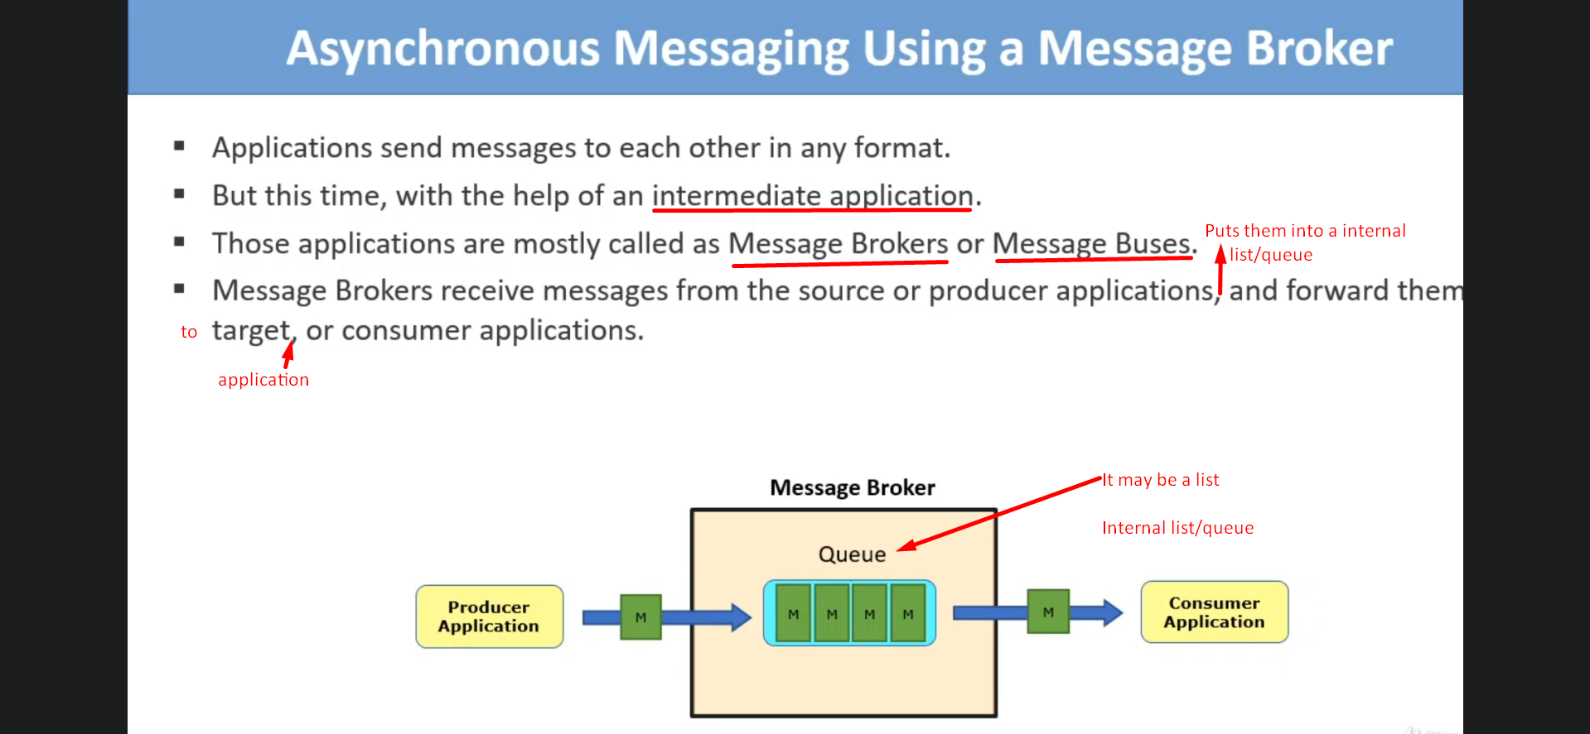
2. It receives message from the source/producer application and puts them into an internal List/ Queue.